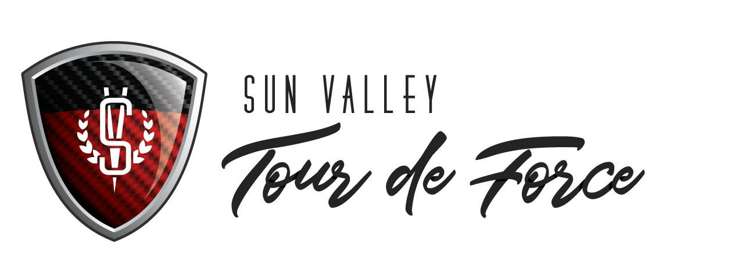
Nonprofit Recipient Application

General Information:

- What is the name of your organization? Include mailing address, physical location, 501(c)(3) number, and number of active years in the community.

- What is the mission of your organization?

- What population do you serve? How many individuals does your programs serve?

- Tell us something about your organization that you wish more people knew.

- Are you more staff or volunteer driven? How many people are on your staff? Do you have a designated PR/ marketing / social media role, either paid or volunteer?

- Is your organization active on social media? What platforms do you use?

- Do you have an active email mailing list?

- Do you host fundraising events throughout the year? What is the size and scope?

- Does your organization have events or activities planned in the summer? What are the dates?

- How well does the local community know and understand your organization? Would you say you have strong community awareness?

- Tell us why Sun Valley Tour de Force should choose your organization.

Thank you for your time and interest!

